**Electric Vehicles: The Limits and Potential of Adopting in Rural America**

**Paul Tetreault**

Department of Statistics

Castleton University

pat09111@csc.vsc.edu

**Jason Hawkins Ph.D. (corresponding author)**

Assistant Professor

Department of Civil & Environmental Engineering

University of Nebraska Lincoln

jason.hawkins@unl.edu

Word Count: 3,812 words + 1 table (250 words per table) = 4,062 words

*Submitted August 01, 2022*

**ABSTRACT**

Transportation is a major source of climate change-inducing greenhouse gas (GHG) emissions. All transportation must be decarbonized if we are to address this challenge. One of the key strategies to achieve this objective for the United States is electrifying personal vehicles. This strategy is particularly important in rural areas where other options (e.g., fixed rail transit, active travel, and upzoning) are less feasible. We use charging station and vehicle registration data to explore potential disparities between urban and rural regions of the United States. We find an apparent lack of charging stations in the mostly rural central plains. Vehicle registration data suggest differences in the vehicle fleets between urban and rural contexts, which we incorporate into our analysis by adjusting the electric vehicle fleet. After performing one-way ANOVA tests based on the NHTS urban-rural codes, statistical significance variations are found for percent truck owners, trip distance, and differences in EV battery use for trips if vehicle owners were to have the EV equivalents of their current vehicle. There are increased distances traveled by individuals who live in more rural areas. More rural areas also have more trucks. Rural households are expected to use more EV battery charge in a day than urban households.

**INTRODUCTION**

In the 21st century, the transition to renewable energy and the phasing out of technology that uses non-renewables is crucial to the earth’s ecological sustainability by lowering anthropogenic greenhouse gas (GHG) emissions. The transportation sector is among the largest contributors to greenhouse gas emissions in the United States at about 27 percent in 2020 (U.S. Environmental Protection Agency, 2021). Electrifying personal vehicles is crucial in rural areas where public transportation infrastructure is insufficient to serve most trips and ownership of EVs is the lowest. The International Transport Forum (ITF) identifies a “strong urban-based myopia” in transportation planning for a low carbon future (2021). While rural regions are home to only 20 percent of Americans, their roads carry nearly 70 percent of American vehicle miles (U.S DOT, 2022). As such, these regions must contain sufficient charging infrastructure to support EV adoption, as well as that these residents adopt such vehicles. Unfortunately, rural areas of the county also suffer from a lower baseline knowledge about EVs.

The Biden-Harris administration plans to add 500,000 new charging stations across the United States (Lunney, 2022). Knowing the locations with charging station disparities will be crucial to ensure full coverage for EVs to enable their use across the country. Cost cannot be ignored when considering EV adoption. The average transaction cost for an EV is $56,437 according to Kelley Blue Book, whereas the industry average costs $46,329 which includes both gas and electric vehicles. (Winters, 2021). The necessity of allowing complete accessibility and mobility to the population of America is important to justify the costs. Consumer Reports National EV Survey nationally representing the U.S with 3,392 adult drivers conducted by phone and Internet from July 29 through August 12 of 2020 surveyed their respondents if they planned to purchase or lease an EV. Only 4% said they were “definitely planning” to lease or buy an EV. The other 96% were then asked what, if any, was holding them back from buying or leasing EVs, which they were allowed to choose three. The top three choices were “Not enough public charging stations”, “Purchase Price”, and “Insufficient driving range”. The response percentages being 48%, 43%, 42% respectively (CR, 2020).

Rural America must have an answer to accessibility and mobility to live comfortably. Accessibility is defined as the availability to access amenities and services and mobility is defined as the ability to travel. If the nearest store is 50 miles away, but you have a motor vehicle to reach it, your accessibility is poor, but your mobility is good. Rural Americans typically have low accessibility, so private vehicles are necessary to survive. As a rule-of-thumb, effective public transit requires a minimum of 35 dwellings per acre (Santasieri, 2014). Given the necessity of personal vehicles in rural areas, the replacement of gas fuels for battery electric is important to limit GHG emissions and improve environmental sustainability. Accessibility requirements change in rural areas when electric vehicles are involved. Charging stations are sparser in rural areas, so accessibility can become tied to mobility even further because the EV may not be able to reach a charging station in a reasonable amount of time to make it to any given place.

The U.S census reports that about 19% of the population or 61 million people lives in rural areas which encompasses 97% of the total land area in America (U.S Census, 2017). Due to the rural dispersion, rural drivers travel more than urban drivers, with rural residents driving 33% more and rural workers driving 38% more, and low-income rural driving 59% more annually (Litman, 2022). The rural landscape is filled with farmland and forest depending on location, and that leads to a lack of infrastructure being built to serve communities. The land is instead utilized in farming, preservation, and in some circumstances like in mountainous regions of Vermont and Colorado, the landscape is difficult to maintain. Rural landscapes are not maintained as closely or frequently leading to less accessibility than urban areas.

The necessity for the adoption of EVs not only for the environment but financially is apparent only in the areas where the application of EVs for the public has been enabled. Looking to places like California where an estimated 22% to 56% of budgets are spent on maintaining 1-2 cars in working order (University of California, 2022). The most fuel-efficient vehicles such as EVs are out of reach financially for many rural residents (University of California, 2022). With such disparity in access to EVs, pilots for EV car sharing such as Míocar have been put in affordable housing complexes in the southern San Joaquin Valley. The combination of access to EVs and charging stations allows for advancements in the transportation sector to limit emissions and enable savings for those less fortunate.

In this paper, we investigate the ability of electric vehicles (EVs) to satisfy the travel requirements of rural Americans and the potential challenges and advantages that come with that transition. In addition, we examine whether there is a deficiency in the spatial allocation of charging stations relative to travel demand for rural Americans. We begin with a review of the literature on rural transportation and electrification. We then detail our data and methods. Qualitative and quantitative results are provided, followed by concluding remarks on our findings and recommendations.

**LITERATURE REVIEW**

In rural areas, there are transportation deficiencies such as access for transportation to those in rural living situations to the preparation of rural America for electrical vehicles. Research by Pyrialakou, Gkritza, and Fricker (2016) investigate rural living by using a case study of Indiana. They create a replicable and extensible approach to account for three essential transport disadvantage elements: accessibility, mobility, and travel behavior. The authors find that the United States has lagged behind other nations in investigating transport disadvantage and exclusion. Transport exclusion can take the form of physical and psychological barriers, geographic exclusion, economic exclusion, and time-based exclusion. Rural regions are particularly affected by geographic and economic exclusion, which takes the form of extensive travel times and lack of access to employment.

A lack of accessibility for those in rural areas due to a lack of reliable transportation impacts the ability to access resources for living. Research by Rojas, Ke, Pyrialakou, and Gkritza (2021) investigates how lack of reliable transportation leads to barriers to healthy food access. The researchers display this by using a cost-based accessibility measure and spatial econometric estimates to identify rural and urban differences in accessibility to healthy foods. The results show urban areas as having lower average costs to reach healthy foods as compared to rural areas, especially when walking and driving are considered. These results exacerbate the issues that stem from living rural and the need for improving the accessibility of the rural populace.

There is work being done to improve the rural lifestyle through policy and investigation. Research by the International Transport Forum (2021) investigates and presents the best practices and recommendations for transportation provisions from more than 80 case studies from more than 20 countries collected through questionnaires, workshops, and interviews. One of the discoveries is short term, program-specific, funding is a major block to the delivery of integrated transportation services. Instead of trying to copy urban transportation innovations, rural areas should develop their own mobility innovations, but policymakers are yet to develop the framework for such innovations. The ITF recommends funding pilots and new initiatives. With the recommendation from the ITF, pilot programs such as Míocar would be far more frequent and varied allowing for the chance of major advancements in the transportation sector.

Rural electrification also suffers from a variation in the electricity grid composition between predominantly urban and rural regions of the country. Research by Yuksel et al. (2016) highlights this disparity by comparing the life cycle GHG emissions for several gasoline fuel vehicles against emissions for electric vehicles. Midwestern and southern states tend to have higher emitting grids. Further, they find variation within these states, with urban counties being outliers and having lower GHG emissions profiles. These results suggest a secondary inequity in the effectiveness of EV adoption in rural counties. To support adoption, it is necessary to lower the GHG emissions intensity of the grid in these states. Otherwise, rural Americans may view an EV purchase as an ineffective way to reduce their GHG emissions.

Liu and Kontou (2022) define an energy vulnerability index for the United States based on the share of income spent on transportation, sensitivity to energy prices as measured by poverty rate and minority population proportion, and adaptive capacity as measured by the availability of alternative forms of transportation (e.g., public transit). While their analysis is conducted for all US census tracts, the analysis focuses on three major urban centers: New York, Los Angeles, and Chicago. Fortunately, Liu and Kontou have made their data and code openly available[1]. We apply their exposure measure to Nebraska (see results below).

**DATA AND METHODS**

Our primary data sources are vehicle registrations provided by Experian Inc. and the National Household Travel Survey (NHTS). Detailed vehicle registration data were purchased from Experian describing vehicle make, model, powertrain, and many other features. The dataset includes total vehicle registrations by feature combination for each county in the United States.

We use the six 2013 Rural-Urban Continuum Codes developed by the federal Office of Management and Budgets (OMB) to classify counties in the Experian data. To unify the coding with NHTS data, the six-code system is recoded to match the four-code NHTS system:

1. Addresses located in Metropolitan Statistical Areas (MSAs) with access to heavy rail transit and more than one million people
2. Addresses located in MSAs with more than one million people but no access to heavy rail transit
3. Addresses located in MSAs with fewer than one million people
4. Non-MSA addresses (i.e., rural areas or small towns)

The US EPA provides a vehicle database by model year that includes the rated range for EVs. We aggregate vehicles in the EPA data into three classes: passenger cars, SUVs, and pickup trucks. We then combine these driving range statistics with vehicle registrations to estimate an expected EV range. That is, the average range assuming that all registered vehicles in the county are swapped for their equivalent EV. These county averages are then used to test for variation along the urban-rural continuum and in subsequent analysis.

The NHTS data are used to find the mean and distribution of daily vehicle miles traveled (VMT) grouped by urban-rural code. With the vehicle distribution and urban-rural code known for each county, we can generate statistics by urban-rural code that are weighted by county vehicle populations. These values can be combined with the expected EV range to define a sufficiency measure (SM) as follows

$$SM = \frac{Vehicle Travel Distance}{E(EV Range)}$$

An SM > 1 denotes daily vehicle use that exceeds the expected single charge vehicle range while an SM < 1 denotes use that can be accomplished on a single charge. Differences between urban-rural codes can be statistically compared using a 1-way ANOVA test. Within-code variation can also be plotted by comparing SM values across NHTS vehicles and applying their sampling weights.

Transportation is an inherently spatial process. We use GIS to spatially locate EV charging stations. Census populations are assigned to block group centroids, which are then used to calculate the number of charging stations within a 1-mile radius. Using these smaller spatial units, rather than counties, allows us to calculate a weighted average station count that captures the population distribution within each county.

**RESULTS**

**Transportation Energy Exposure**

As a first analysis, we make use of open science to apply the transportation energy index developed by Liu and Kontou (2022). While they focus on three major metropolitan areas, their analysis can be filtered to focus on other regions of interest. Here we focus on the central plains state of Nebraska and transportation energy burden exposure. Exposure $e_{i}$ is measured as the ratio of average fuel expense $c_{i}$ and median household income $W_{i}$ per census tract. Fuel expense is approximated as the product of annual household travel (in miles), vehicle fuel efficiency (in gal or kWh per mile), and fuel price (in dollars per gal or kWh). Figure 1 highlights several important insights about transportation energy equity. First, variation exists between rural areas depending on their proximity to urban centers. Rural census tracts in eastern Nebraska, close to Lincoln and Omaha, have lower exposure indices than the more remote western Nebraska tracts. Second, the highest exposure indices are mostly located in the City of Omaha. That is, while rural tracts face longer travel distances, low-income urban census tracts may face higher exposure to energy vulnerability. These results suggest that the sustainable transportation solutions for underserviced rural settings likely differ from those in urban settings.

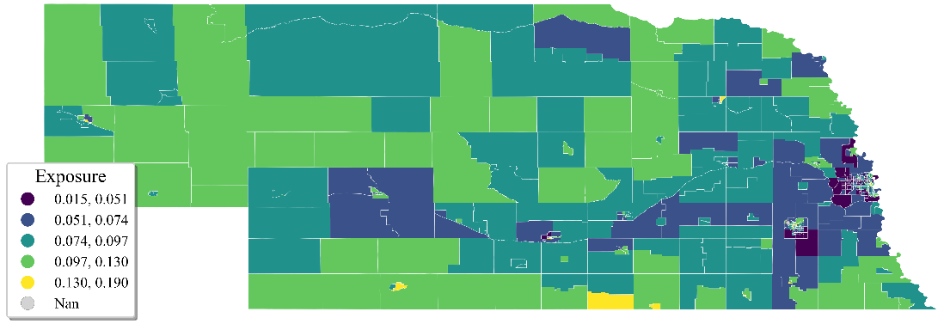

See Figure 1 (b)

(a)

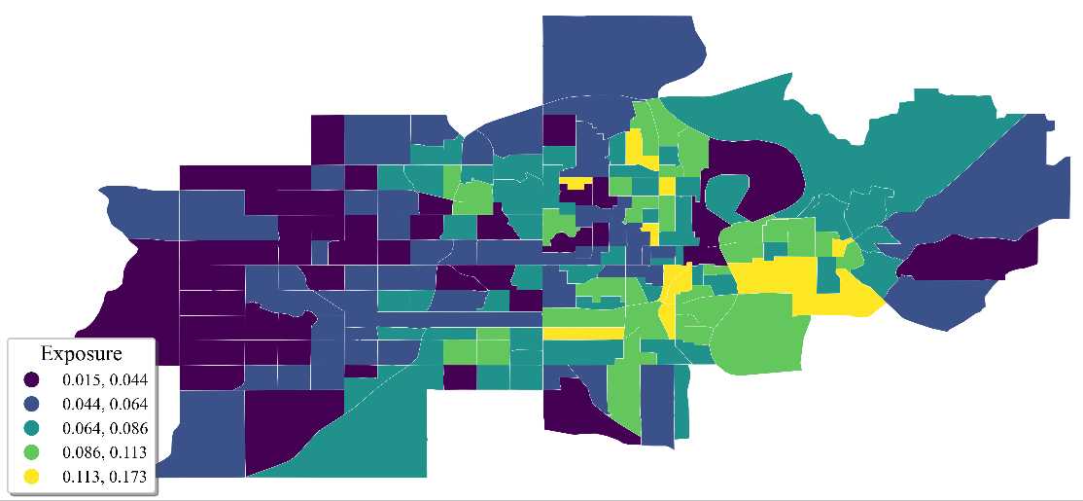

(b)

**Figure 1** Transportation Energy Exposure for a) Nebraska and b) Omaha, NE

**Charging Station Access**

Figure 2 shows the count of stations within 1 mile by county weighted by block group population. There is a band of low charging access through the central plains states (North and South Dakota, Nebraska, and Kansas) and Montana.

**Figure 2** Spatial map of charging stations within 1 mile

**Rural Transportation Characteristics**

A summary of travel distances by urban-rural code is given in Table 1. We conduct a one-way ANOVA test based on these NHTS data and our urban-rural continuum codes. We find a statistically significant difference in vehicle miles traveled (VMT) between urban and rural households.

**Table 1 Summary of Household Vehicle Daily Travel Distance (population weighted)**

|  |  |  |  |  |  |  |
| --- | --- | --- | --- | --- | --- | --- |
| **Urban-Rural Code** | **Minimum** | **1st Quartile** | **Median** | **Mean** | **3rd**  **Quartile** | **Maximum** |
| 1 (highly urban) | 0.00 | 9.3 | 18.7 | 25.4 | 34.9 | 100.6 |
| 2 | 0.04 | 10.7 | 21.7 | 27.2 | 38.0 | 100.6 |
| 3 | 0.00 | 11.1 | 23.4 | 28.9 | 41.3 | 100.7 |
| 4 (highly rural) | 0.00 | 11.1 | 24.6 | 31.2 | 45.8 | 100.7 |

Looking at the trip distance of vehicles from the NHTS data, a one-way ANOVA based on NHTS urban-rural continuum codes found there to be a highly statistically significant difference in trips. With three degrees of freedom, with a significance at more than the .001 level, which indicates that trip distances depend on rural/urban region.

Analyzing Vehicle EPA data looking at electric vehicle ranges, the averages for each of the three most common personal vehicle types are shown below.

* Average range of electric car = 226 miles (205 models on record)
* Average range of electric SUV = 264 miles (89 models on record)
* Average range of electric truck = 291 miles (4 models on record)

Vehicle registration data for the current fleet is combined with EPA data to approximate a weighted mean EV range by county (see Figure 3). The mean range across counties is 245 miles.

**Figure 3** Expected Range per County

As a second application of the vehicle registration data, we calculate the percent of personal vehicles that are pickup trucks in each county. This percentage varies from 64% in the most urban counties to 71% in the most rural counties. A one-way ANOVA test confirms that this difference is statistically significant.

**Rural Transportation Electrification Disadvantage**

After the calculations, organization, and aggregation of the various data sources, what has been discovered is that living in rural and urban regions has a statistically significant effect on the type of vehicle. Living in rural and urban regions also has a statistically significant effect on the total battery use if all vehicle owners were to have the EV equivalent of their vehicle. The expected EV ranges of NHTS regions are:

* 1 = 238.9 miles
* 2 = 241.8 miles
* 3 = 243.4 miles
* 4 = 249.7 miles

The percentage of battery used by weighted vehicle travel distance came out to be:

* 1= 12.13%
* 2= 11.98%
* 3= 11.90%
* 4= 11.60%

With those discoveries, a one-way ANOVA was calculated that looked at the percent usage of an EV battery if trips for counties utilized EVs instead of gas-powered vehicles. There is a statistical significance at more than the .001 level, which indicates that the percent battery use of an EV for trips is different depending on what region the vehicle user is residing in.

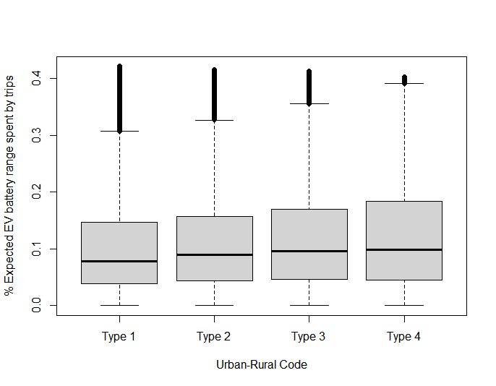

**Figure 4** Boxplot of NHTS Urban-Rural Code Expected battery used per trip per vehicle

Utilizing the NHTS 4 type Urban-Rural Code mentioned earlier in the paper on page 4 and % expected battery range usage by trips per vehicle, a box and whisker plot in the above figure 3 was calculated. Figure 3 shows similar median values, but as the region turns from urban to rural, the highest % battery usage comes from the type 4 region where drivers are farthest from urban areas.

**CONCLUSIONS**

Electric vehicles are the future of the transportation sector. Anthropogenic greenhouse gas (GHG) emissions will be reduced with the gradual electrification of personal vehicles. The necessity of supplying enough charging stations for the country both urban and rural in places where there is a deficit is important. The data shows that with today's average distance for various Electric vehicle types. In the future, EVs will continue to be able to reach further and further distances on a single charge, but for now the only way to help facilitate fleet electrification is more charging stations. The market for electric vehicles will continue to expand and include more and more types of vehicles. With the expansion of programs to provide access to EVs as ride-sharing rentals, it is only time until there are ride-sharing hubs in other areas of the country. Preparing the rural areas of America to have the infrastructure to provide EVs the power they need will increase mobility and accessibility for the whole country allowing the transition to EVs to be possible. With the disparity of charging stations shown in the Midwest of America, there is work to be done to provide the option for EVs to all Americans.

Future work could use a more robust urban/rural classification that incorporates transportation elements. For example, Subedi et al. (2020) developed a continuous classification for Canada based on transportation cost. This approach would recognize that density does not capture variation between rural areas by their proximity to urban centers.

**ACKNOWLEDGEMENTS**

Funding for this work was sponsored in part through an award from the National Science Foundation (EEC-1950587) for the REU Site “Sustainability of Horizontal Civil Networks in Rural Areas”.

**AUTHOR** **CONTRIBUTIONS**

The authors confirm contribution to the paper as follows: study conception and design: J. Hawkins; data collection: J. Hawkins; analysis and interpretation of results: P. Tetreault and J. Hawkins; draft manuscript preparation: P. Tetreault and J. Hawkins. All authors reviewed the results and approved the final version of the manuscript.

**REFERENCES**

Baatar, B. (2019). Preparing rural America for the Electric Vehicle Revolution. Retrieved June 21, 2022, from <https://epm.ucdavis.edu/sites/g/files/dgvnsk296/files/inline-files/Preparing%20Rural%20America%20for%20the%20Electric%20Vehicle%20Revolution.pdf>

Census.gov. (2019). Understanding and Using American Community Survey Data: What Users of Data for Rural Areas Need to Know Retrieved July 17, 2022, from <https://www.census.gov/content/dam/Census/library/publications/2019/acs/ACS_rural_handbook_2019.pdf>

CR Survey Research Department and Advocacy Division. (2020, December). Consumer Interest and knowledge of EVs - CR Advocacy. National EV Survey. Retrieved July 31, 2022, from <https://advocacy.consumerreports.org/wp-content/uploads/2020/12/CR-National-EV-Survey-December-2020-2.pdf>

ITF. (2021). Innovations for Better Rural Mobility. ITF Research Reports. Retrieved July 31, 2022, from <https://www.itf-oecd.org/sites/default/files/docs/innovation-rural-mobility.pdf>

Litman, T. (2022). Rural Multi Modal Planning - vtpi.org. Retrieved July 17, 2022, from <https://www.vtpi.org/rmp.pdf>

Liu, S., &amp; Kontou, E. (2022, March 25). Quantifying transportation energy vulnerability and its spatial patterns in the United States. Sustainable Cities and Society. Retrieved July 31, 2022, from <https://www.sciencedirect.com/science/article/pii/S2210670722001342>

Losada-Rojas, L. L., Ke, Y., Pyrialakou, V. D., & Gkritza, K. (2021). Access to healthy food in urban and rural areas: An empirical analysis. Journal of Transport & Health, 23, 101245. <https://doi.org/10.1016/j.jth.2021.101245>

Lunney, K., &amp; Byington, L. (2022). Biden officials plan electric vehicle equity, charging event (1). Bloomberg Government. Retrieved July 30, 2022, from <https://about.bgov.com/news/biden-officials-plan-electric-vehicle-equity-charging-event-1/#:~:text=The%20events%20come%20as%20President,to%20aid%20in%20that%20effort>.

Pyrialakou, V. D., Gkritza, K., & Fricker, J. D. (2016). Accessibility, mobility, and realized travel behavior: Assessing transport disadvantage from a policy perspective. Journal of Transport Geography. Retrieved June 21, 2022, from <https://www.sciencedirect.com/science/article/pii/S0966692316000144>

Rodier, C., Harold, B., &amp; Zhang, Y. (2022). A before and after evaluation of shared mobility projects in the San Joaquin Valley. eScholarship, University of California. Retrieved July 27, 2022, from <https://escholarship.org/uc/item/7nr194n7>

Santasieri, C. (2014, June). Planning for Transit-Supportive Development: A Practitioner’s Guide . Federal Transit Administration. Retrieved July 31, 2022, from <https://www.transit.dot.gov/sites/fta.dot.gov/files/FTA_Report_No._0052.pdf>

Subedi, R., Roshanafshar, S., & Greenberg, T. L. (2020, August 11). Developing Meaningful Categories for Distinguishing Levels of Remoteness in Canada. Retrieved July 31, 2022, from <https://www150.statcan.gc.ca/n1/pub/11-633-x/11-633-x2020002-eng.htm>

Sullivan, J. S., Clouser, K., & Shaw, J. (2022). Rural Transportation Issues: Research Roadmap. Retrieved July 17, 2022, from <http://nap.naptionalacademies.org/26343>

U.S Census Bureau. (2017). Defining “Rural” Areas. census.gov. Retrieved July 31, 2022, from <https://www.census.gov/content/dam/Census/library/publications/2019/acs/ACS_rural_handbook_2019.pdf>

U.S Department of Transportation. (2022). Charging forward: A toolkit for planning and Funding Rural Electric Mobility Infrastructure. U.S. Department of Transportation. Retrieved July 31, 2022, from <https://www.transportation.gov/rural/ev/toolkit>

U.S. Environmental Protection Agency. (2022). Sources of Greenhouse Gas Emissions. EPA. Retrieved July 30, 2022, from <https://www.epa.gov/ghgemissions/sources-greenhouse-gas-emissions>

University of California, D. (2022, July). Implementing and evaluating a Rural Electric Mobility Program: National Center for Sustainable Transportation. U.S. Department of Transportation. Retrieved July 27, 2022, from <https://www.transportation.gov/utc/implementing-and-evaluating-rural-electric-mobility-program-national-center-sustainable>

Winters, M. (2021, December 29). Here's whether it's actually cheaper to switch to an electric vehicle or not-and how the costs break down. CNBC. Retrieved July 30, 2022, from <https://www.cnbc.com/2021/12/29/electric-vehicles-are-becoming-more-affordable-amid-spiking-gas-prices.html>

Yuksel1, T., Tamayao, M.-A. M., Hendrickson, C., Azevedo, I. M. L., &amp; Michalek, J. J. (2016, March 2). IOPscience. Environmental Research Letters. Retrieved July 31, 2022, from <https://iopscience.iop.org/article/10.1088/1748-9326/11/4/044007/meta>

1. https://github.com/ekontou/Transportation-Energy-Vunerability